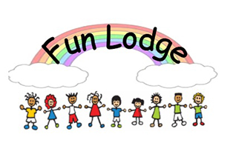
NEWSLETTER October 2018 Tel. 07977215652
Friday Opening
Fun Lodge is delighted to offer our first term time Friday on the 26th October. On these day’s snack options will be different and alternative play opportunities will be on offer.

Children’s Care Plans
All new children have already started their care plans. More will be explained to them as they are encouraged to fill them in on a regular basis. You will have already been informed of your child/children’s key worker and should anyone have any questions then please don’t hesitate to ask a member of staff.

Fun Lodge
Policies and Procedures
As an after school care service our policies and procedures are always being reviewed to fit our requirements. Please look out for amended policies in your emails.
Safety
To ensure all children’s safety we ask that you park outside the church on the roadside when collecting your child/children.
Fees
As you are aware Fun Lodge is self-funding & to ensure the viability of the service fees must be paid either straight in to our bank or by child care vouchers by the 14th of each month. We can no longer accept cash or cheques. Please ensure that this is done at all times or a late payment fee will be charged.
If your child has a term time place you will be charged if we are open and you do not use your place. If we are unable to open you will not be charged. Please see your terms and conditions regarding this.
Permanent changes to your requirements requires one calendar month’s notice in writing.
Reminder!
Can you please ensure that if your child/children are not attending on a set day that you call the Fun Lodge phone BEFORE 10am that day. Do not email as we are not always able to pick these up! If you fail to do this you may be charged a £10 fee.
It is also important that all parents keep their own contact numbers updated with us.

Young Leader’s Play Training
Following the success of last year’s training we plan to once again offer this to our Primary 6 and 7 children after the October Holiday’s. Letters will be emailed to relevant parents.
Planning Tree
With the children’s help we now have designed and made a planning tree which the children will be using to plan their own weekly activities. Please look out for this beside our notice board in the main hallway.
Notice Board
As you may be aware we have now a notice board in the front hallway as you come in the door. This will tell you of our programme of play opportunities on offer for that week. Please take a minute to read this.
Should you ever wish a copy of any of our policies or procedures please ask any member of staff.
Thank you for your continued support.

